Calendar of events 2024
January | Tuesday 16th – Centre reopens  Thursday 26th –Australia day public holiday – Centre closed
February | Saturday 10th - Chinese New Year  Tuesday 13th – Shrove Tuesday (pancake day)  Saturday 24th – Chinese Lantern festival  Tuesday 27th – Thurs 29th – Professional photos (Aver & Line photographers)  Meet and greet drinks – date TBC  Wednesday 28th – BOC committee meeting 7:30pm
March | Sunday 3rd – Clean up Australia day  Monday 11th – Labour Day public Holiday – Centre closed  Wednesday 13th – Wednesday 20th – Cultural Diversity Week  Wednesday 20th – Tuesday 26th – Harmony week  Thursday 21st – Harmony Day  Monday 25th – Holi  Friday 29th – Good Friday – Centre Closed  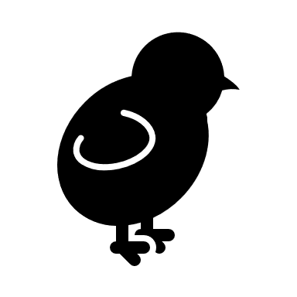  Wednesday 27th – BOC committee meeting 7:30pm  Sunday 31st – Easter Sunday
April |   Monday 1st – Easter Monday – Centre Closed  Monday 22nd – Earth Day  Thursday 25th – Anzac Day – Centre Closed  Wednesday 24th – BOC committee meeting 7:30pm
May | Sunday 5th – Orthodox Easter  Sunday 12th – Mother’s Day    Sunday 5th – Sunday 12th – National Road Safety Week  Sunday 26th – National Day of Healing “National Sorry Day”  Monday 27th – Reconciliation week begins  Educator professional development – date TBC  Trivia night – Date TBC  Wednesday 29th – BOC committee meeting 7:30pm
June |   Monday 3rd – Reconciliation week ends  Monday 10th – King’s Birthday Public Holiday– Centre Closed  Monday 24th – Matariki Day  Wednesday 26th – BOC committee meeting 7:30pm
July | Sunday 30th – Sunday 7th – NAIDOC week  Wednesday 17th – Special Friends Breakfast 7:30am  Friday 19th – National Pyjama Day.  Wednesday 31st – BOC committee meeting 7:30pm
August | Friday 4th – National Aboriginal and Torres Strait Islander Children’s Day    Saturday 10th – Sunday 18th – National Science week  Saturday 17th – Friday 23rd – Children’s Book Week. Theme: Reading is magic  Art show & Wine night – date TBC   Wednesday 28th BOC committee meeting 7:30pm
September | Sunday 1st – Father’s Day  Thursday 5th – Thursday 12th – Child Protection Week  Wednesday 4th – Early childhood educators day  Sunday 8th – International literacy day    Monday 16th – Sunday 22nd – National Recycling Week  Thursday 26th – Footy day TBC  Friday 27th – Grandfinal public holiday Centred closed TBC  Educator professional development – date TBC  Wednesday 25th – BOC committee meeting 7:30pm
October |   Friday 4th – Thursday 10th – World space week  Thursday 31st - Diwali  Bunnings BBQ – Date TBC  Wednesday 30th – BOC Annual General meeting 7:30pm
November |   Tuesday 5th – Melbourne Cup public holiday Centre Closed  Wednesday 20th – World Children’s Day  Wednesday 27th – BOC committee meeting 7:30pm
December | Friday 6th – Kinder Graduation  Friday 13th – Children’s Christmas party    Friday 20th – Last day for the year, centre closing at 6pm  Wednesday 25th – Christmas Day  Wednesday 25th – Hanukkah    Tuesday 26th – Boxing Day
January 2024 | Wednesday 1st – New Year’s Day  Thursday 2nd – Hanukkah ends  Tuesday 14th – Centre reopens 7:30am
Events KEY:
Social/fundraising events Public holidays – centre closed
Committee meetings Professional development – centre closed

